A000-Afr-Mauritania-Dakhlet region- Disc-Annular-

Neolithic basalt annular disc- 14 cm / 5.5"- 6000 to 3000 years BP-from the Dakhlet region, in the Sahara region of Northern Mauritania

Digging sticks were fitted into the hole to increase the fulcrum when digging for tubers.

Case no. 6

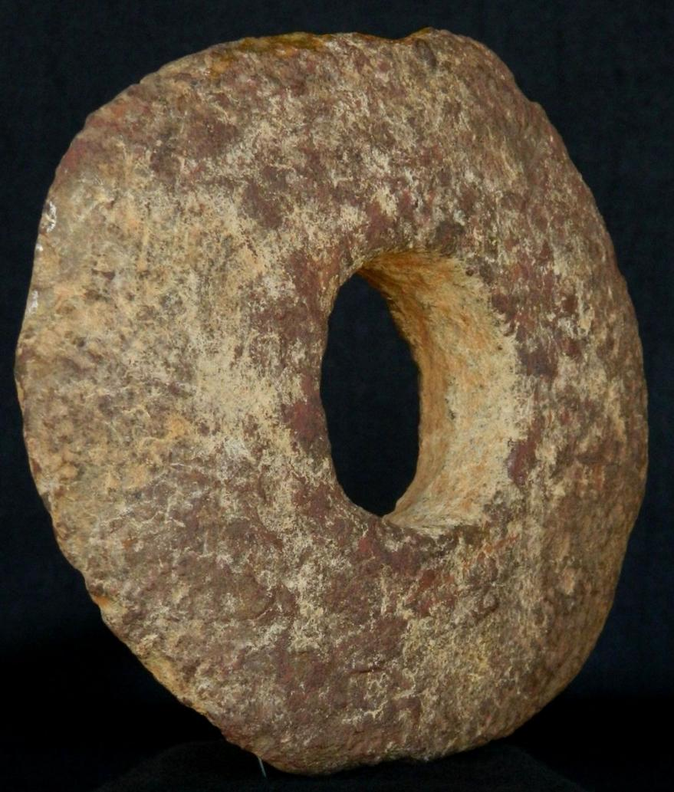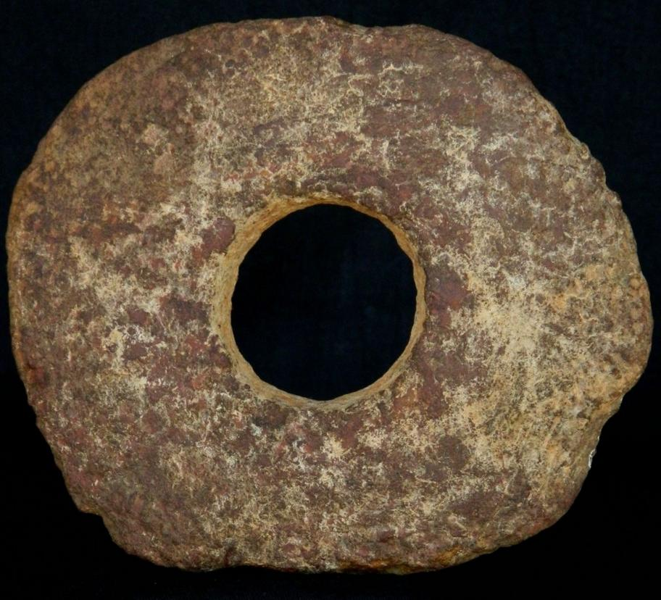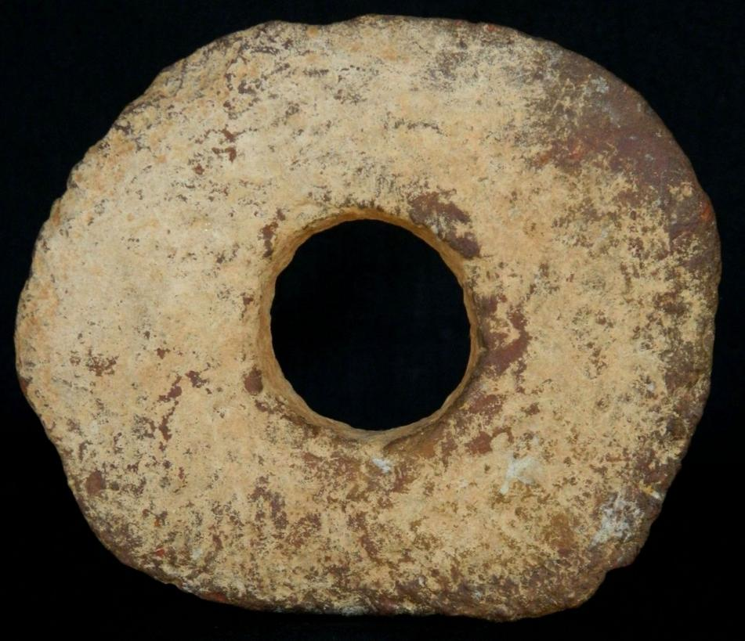 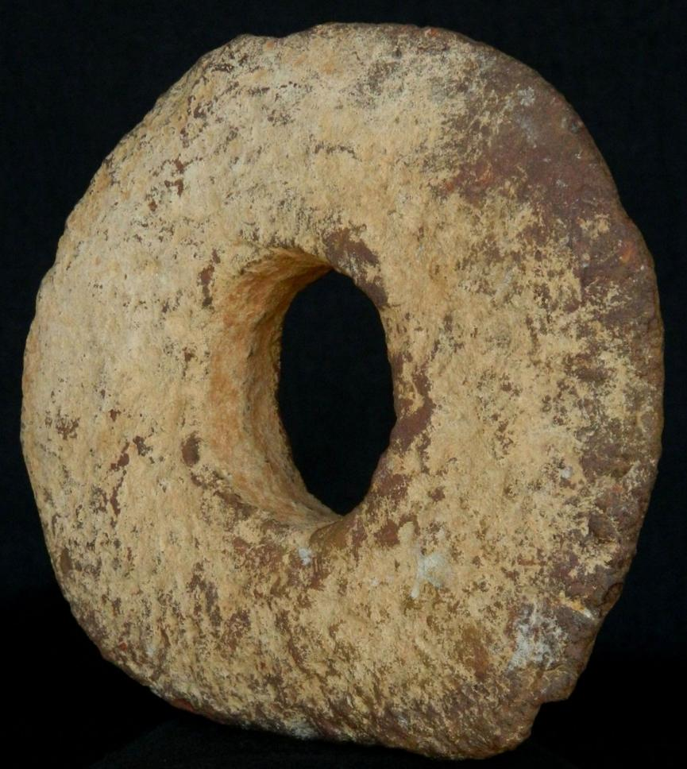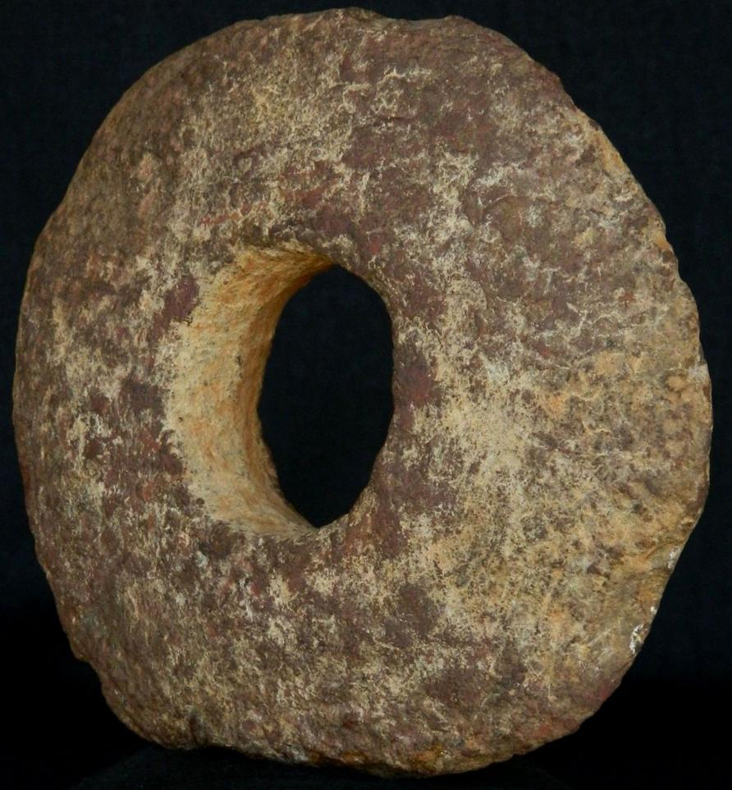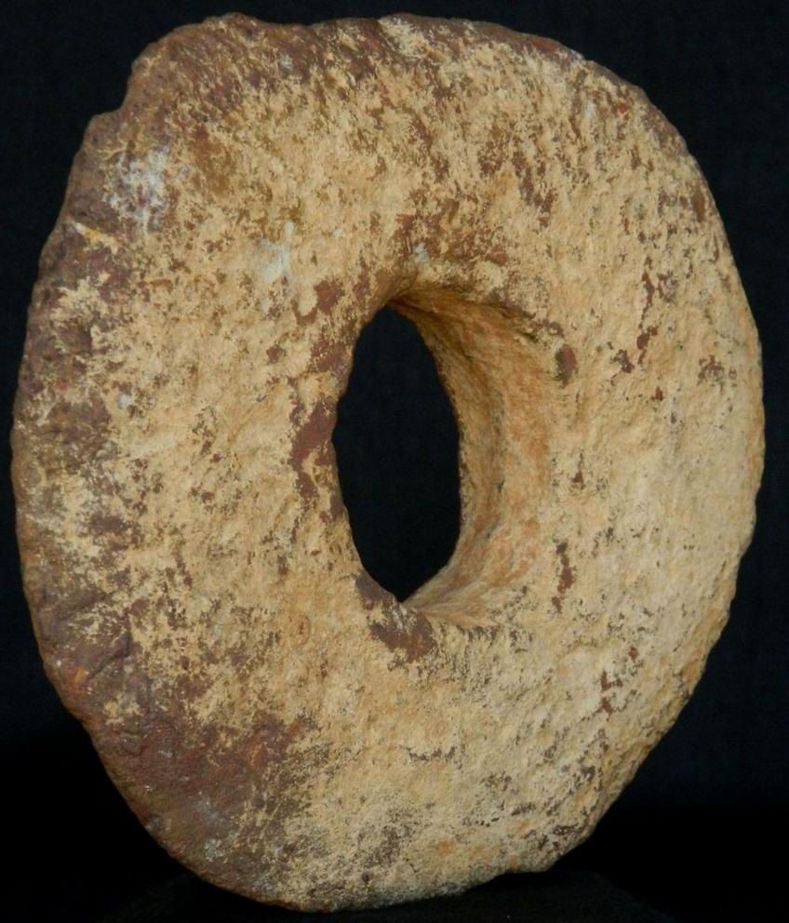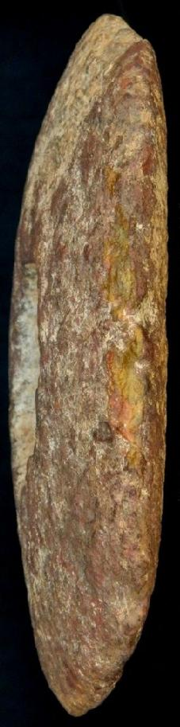

## Sales order

Sold by [kyramint2001](http://myworld.ebay.com/kyramint2001) ( [1825](http://feedback.ebay.com/ws/eBayISAPI.dll?ViewFeedback&userid=kyramint2001) )

+ Show additional actions

### Delivery package 1 of 1

Estimated delivery Tuesday, Jun 14, 2016 -Thursday, Jun 30, 2016

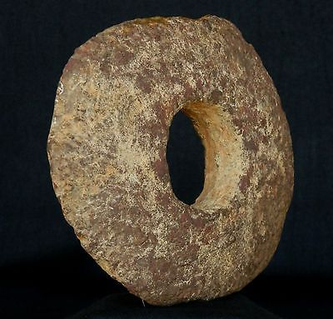

#### [Neolithic Basalt Annular Disc - 14 cm / 5.5"- 6000 to 3000 years BP - Sahara](http://www.ebay.com/itm/301954194597)

|  |  |
| --- | --- |
| **Item price** | $60.00 |
| **Quantity** | 1 |
| **Item number** | 301954194597 |
| **Shipping service** | Economy Shipping from outside US |

[Contact seller](http://contact.ebay.com/ws/eBayISAPI.dll?FindAnswers&frm=3998&iid=301954194597&redirect=0&requested=kyramint2001)

[Return item](https://www.ebay.com/rtn/Return/ReturnViewSelectedItem?transactionId=1261343464020&itemId=301954194597&_trksid=p2057872.m2749.l3185)

## Shipping address

Ralph J Coffman Jr

149 Atlantic Ave

Swampscott MA 01907-2427

United States

## Order total

|  |  |
| --- | --- |
| **Subtotal** | $60.00 |
| **Shipping** | $11.95 |

**Total**

$71.95

[View PayPal transaction](http://payments.ebay.com/ws/eBayISAPI.dll?UnifiedCheckoutSummaryRedirect2PP&itemid=301954194597&transId=1261343464020&buyerorseller=0)

Order placed on

Wednesday, May 25, 2016

Payment method

PayPal

Payment date